Olusegun Afolabi
EECCE 412
Professor Wenjie

Lab 11
Part 1:
- 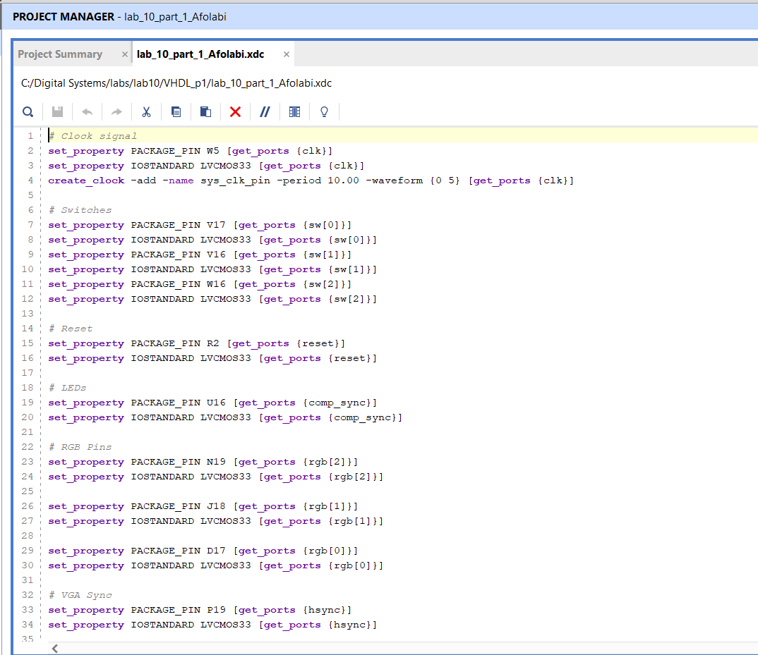
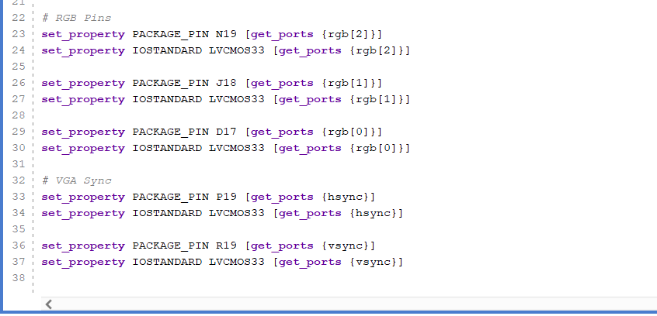
- A. Top-level module
The vga_test module is the top-level entity because it instantiates the VGA synchronization circuit (vga_sync) and ties together the user inputs (sw) and video outputs (hsync, vsync, comp_sync, rgb). In vga_test.vhd you’ll find:
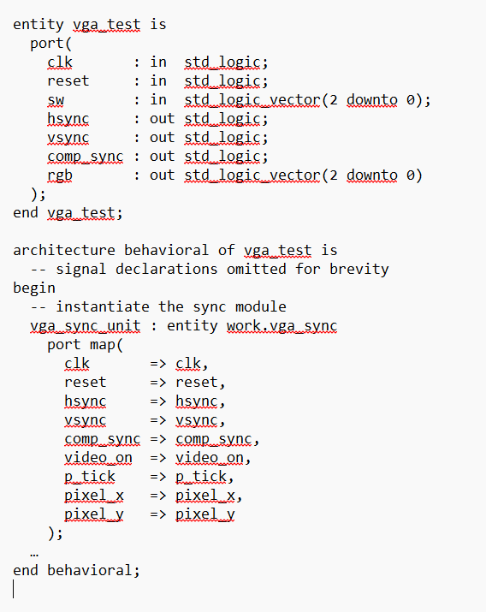
B,
Screen-color control via switches
Within vga_test, a small process captures the 3-bit switch vector sw into an internal register rgb_reg, and then drives the rgb output only when the video signal is active (video_on = '1'). The key code is:
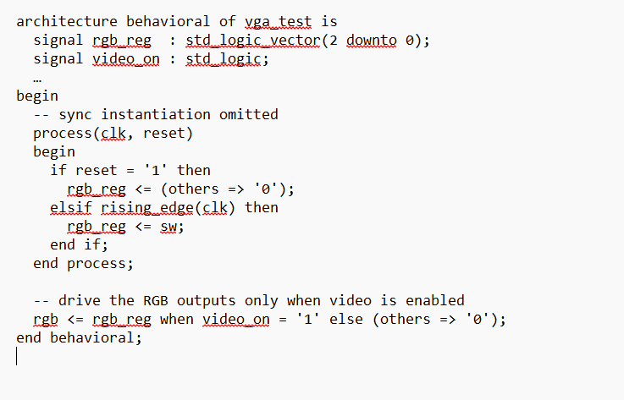
- On each rising clock edge (when not in reset), rgb_reg is updated to reflect the physical switches.
- When video_on is high (i.e. during active video), rgb follows rgb_reg; otherwise the screen is set to black ("000").
C.
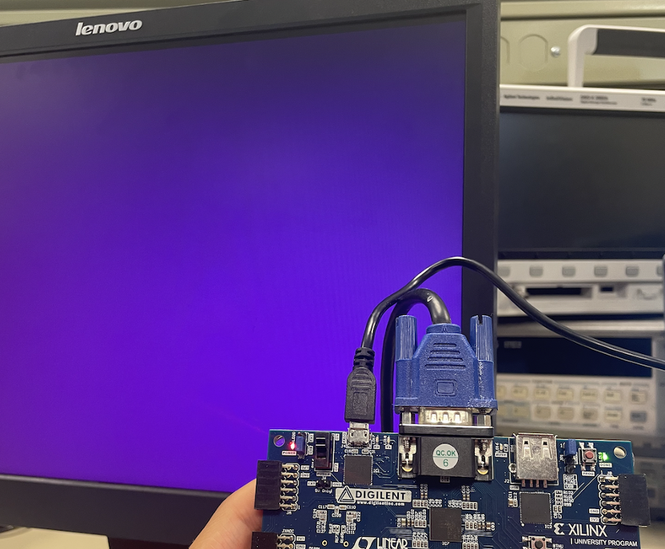
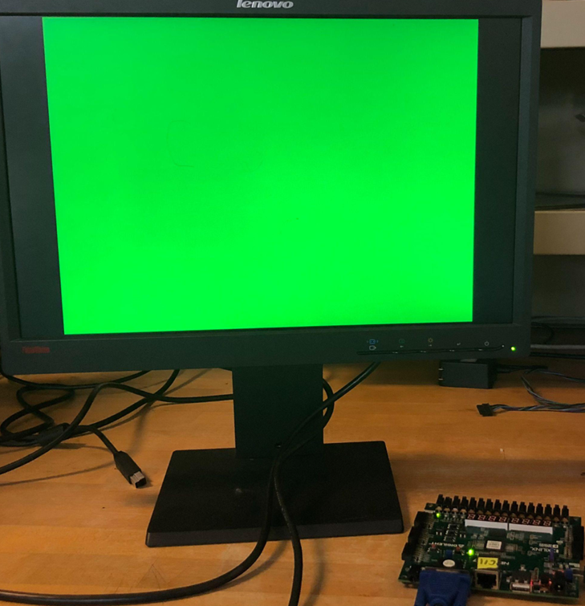
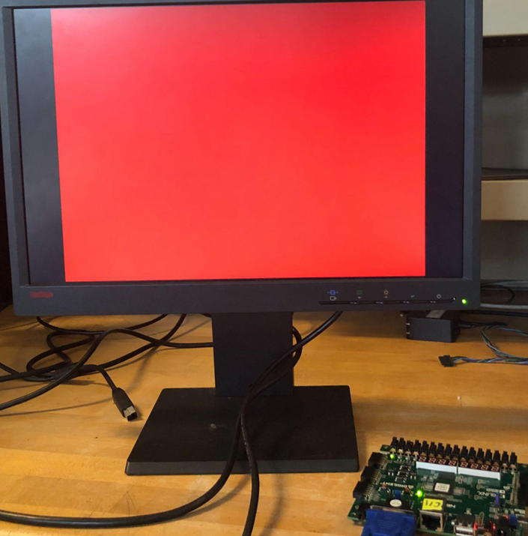
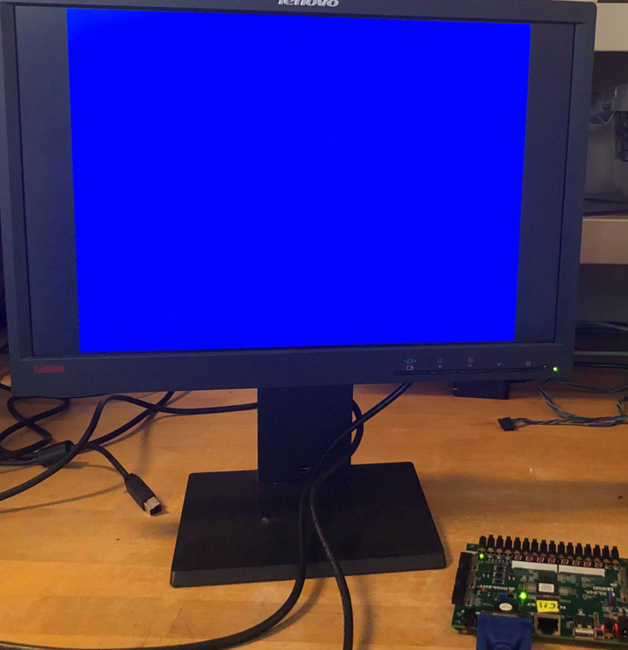

Part 2
- 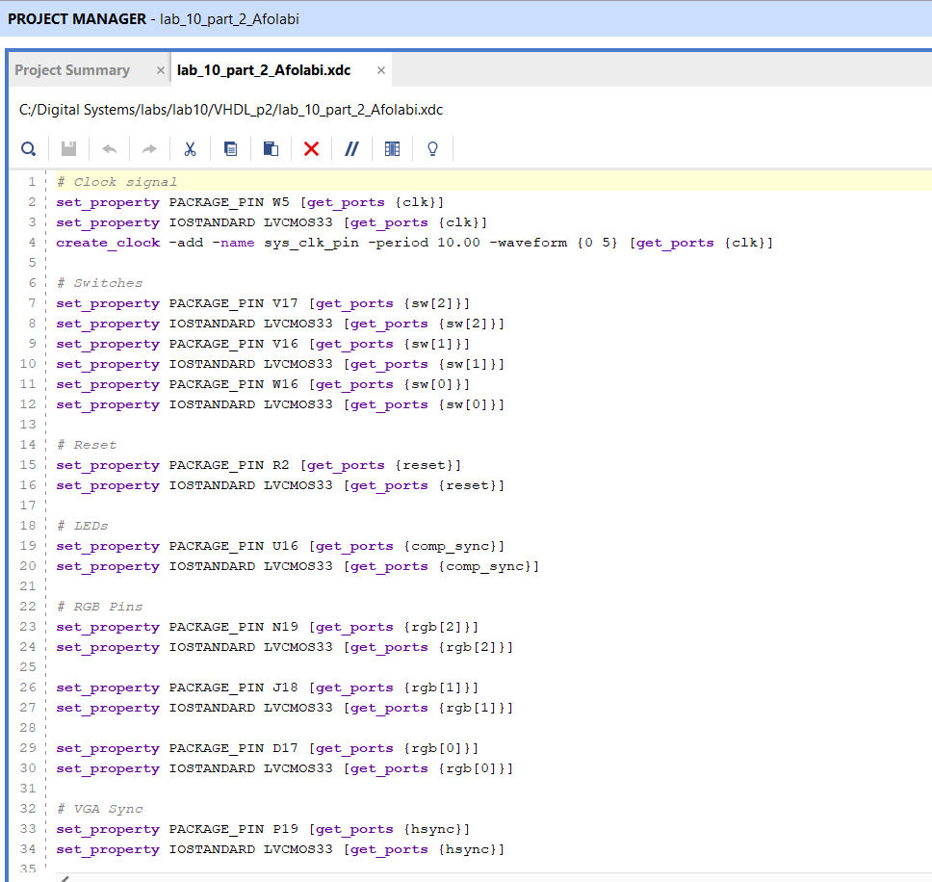
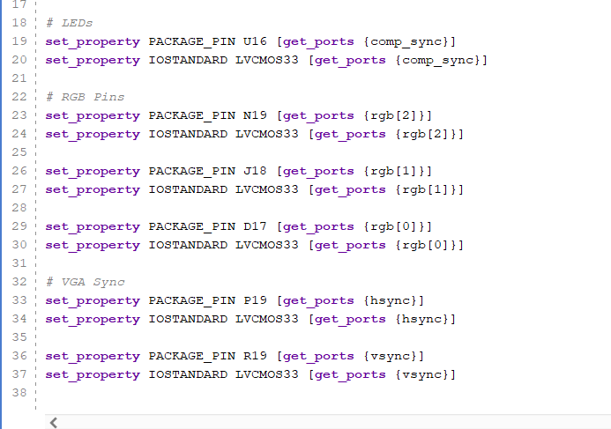
- A. Wall
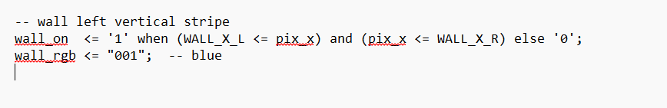
Paddle
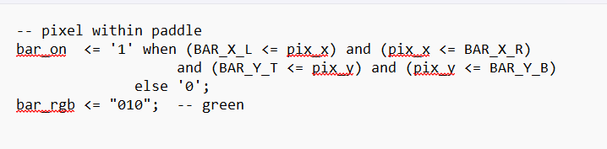
Ball
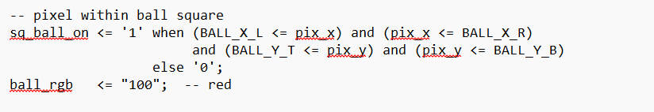
B.
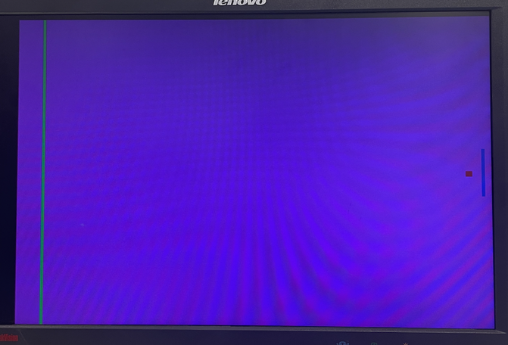

Part 3
- 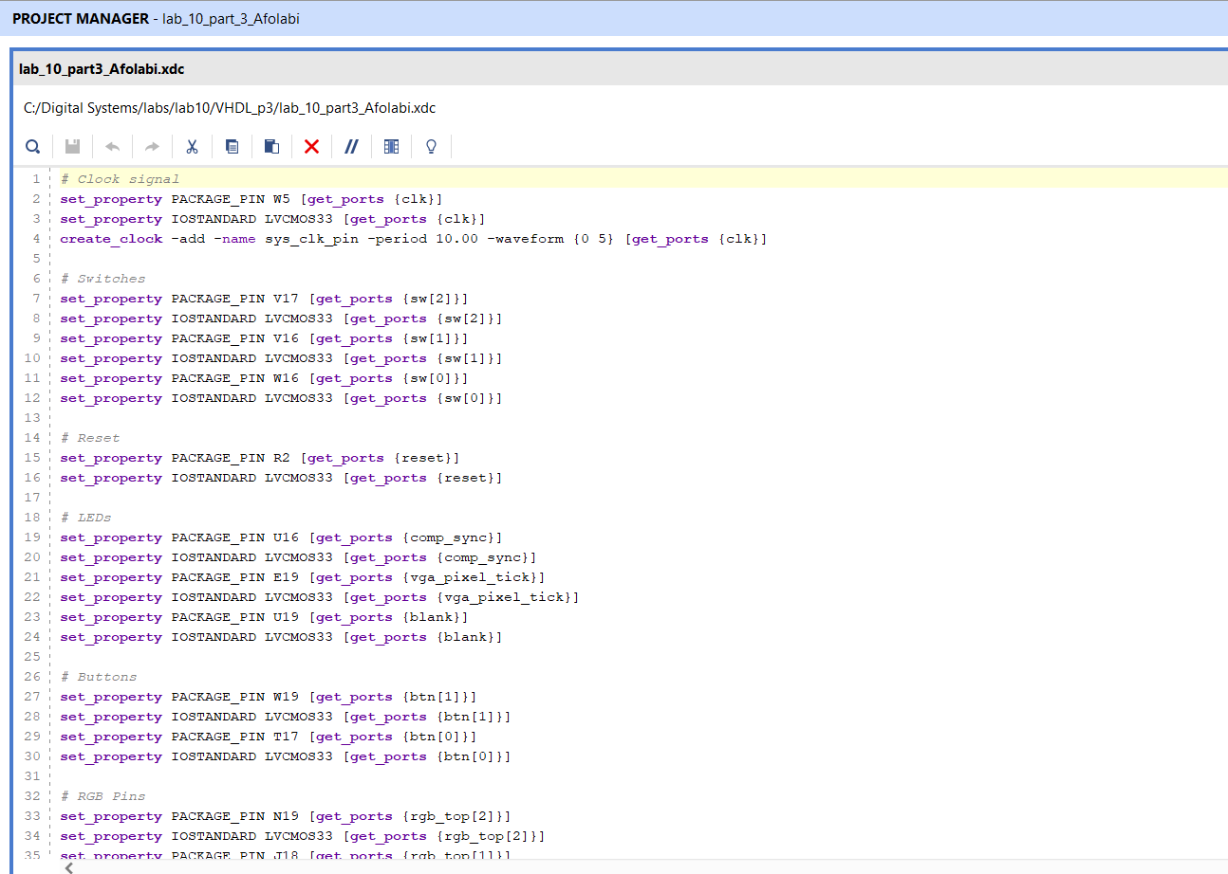
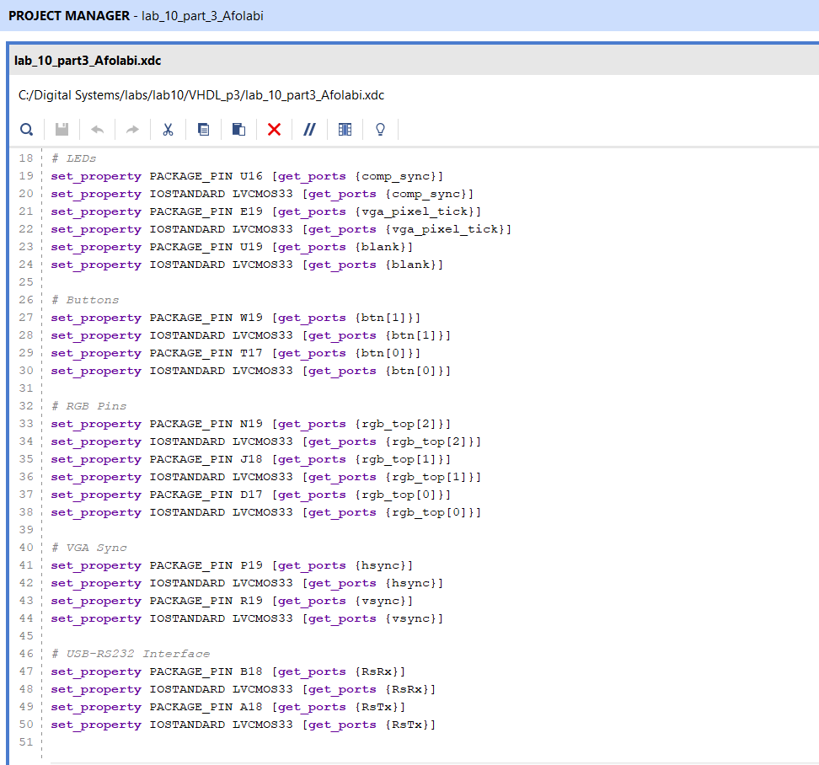
- A. Paddle motion
The right‐hand paddle’s vertical position is stored in a register bar_y_reg. On each screen refresh tick (refr_tick = ‘1’), a small process samples the two push‐button inputs (btn(1) for down, btn(0) for up) and, if the paddle isn’t at the screen edge, increments or decrements bar_y_next by a fixed velocity BAR_V. At the next clock edge, bar_y_reg is updated to bar_y_next, moving the paddle up or down smoothly at 60 Hz.
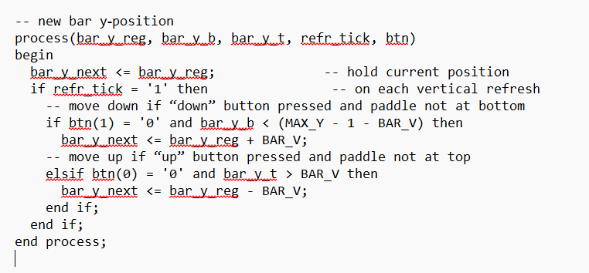
Ball motion
The ball’s position is held in two registers, ball_x_reg and ball_y_reg, and its velocity in x_delta_reg/y_delta_reg. Animation proceeds in two steps, both triggered by the same refr_tick:
Position update
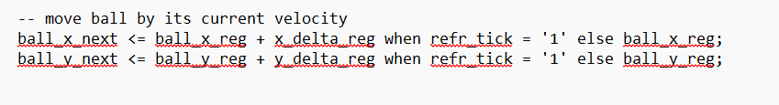
Velocity update on collisions
A second process tests whether the ball has hit the top/bottom of the screen, the left wall, or the paddle. Depending on which boundary is reached, it flips the appropriate component of velocity between the positive constant BALL_V_P and negative BALL_V_N:
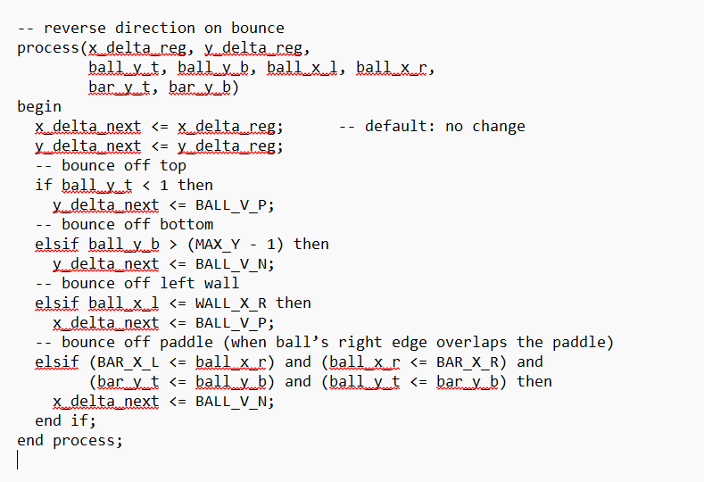

B.
